Market Place Simulator

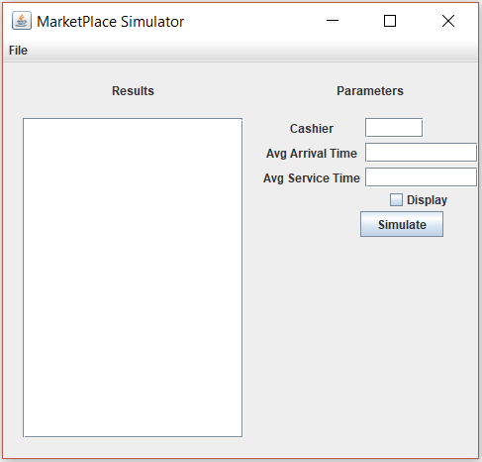

Silas Agnew

I pledge that this work is entirely mine, and mine alone (except for any code provided by my instructor).

I spent 6 hours and 39 minutes on the project from Nov. 16 to Dec. 4. See time sheet on back for more detail.

Time Sheet

|  |  |  |  |  |
| --- | --- | --- | --- | --- |
| Date | Time Started | Time Stopped | Duration | Worked on… |
| 11/16/2017 | 16:10:00 | 17:00:00 | 00:50:00 | Creating classes and methods [done] |
| 11/18/2017 | 01:50:00 | 02:00:00 | 00:10:00 | Finished Events and added assertions and junit |
| 11/18/2017 | 15:00:00 | 15:50:00 | 00:50:00 | Added additional methods for marketplace and  worked on definitions |
| 11/20/2017 | 23:30:00 | 23:59:00 | 00:29:00 | Add more method definitions and comments |
| 11/21/2017 | 00:00:00 | 01:00:00 | 01:00:00 | Add more method definitions and comments |
| 11/21/2017 | 15:45:00 | 16:10:00 | 00:25:00 | Comments and revisions |
| 11/21/2017 | 16:15:00 | 17:15 | 01:00:00 | GUI and troubleshooting |
| 11/28/2017 | 14:10:00 | 15:10:00 | 01:00:00 | MarketTest and other testing and formatting |
| 11/28/2017 | 15:15:00 | 15:50:00 | 00:35:00 | Write-up |
| 12/4/2017 | 00:23:00 | 00:23:20 | 00:20:00 | Revisions and more testing added |
|  |  |  |  |  |
|  |  | Total Time | 06:39:00 |  |

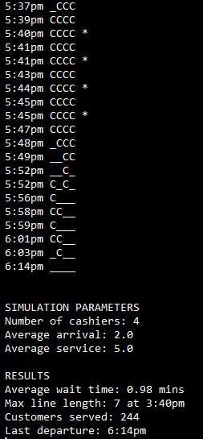Sample Output